WORK SHEET A – Radiation Experiment

Some important facts to help you:

- A black surface is very good at absorbing heat. They are also good at emitting heat.
- White or shiny silver surfaces are very good at reflecting heat. They are poor at emitting heat.

In the following experiment we will attempt to find out which surface is best at absorbing heat. The teacher has already set up the equipment. You will either record your results by reading the thermometer or by using a data logger connected to a computer.
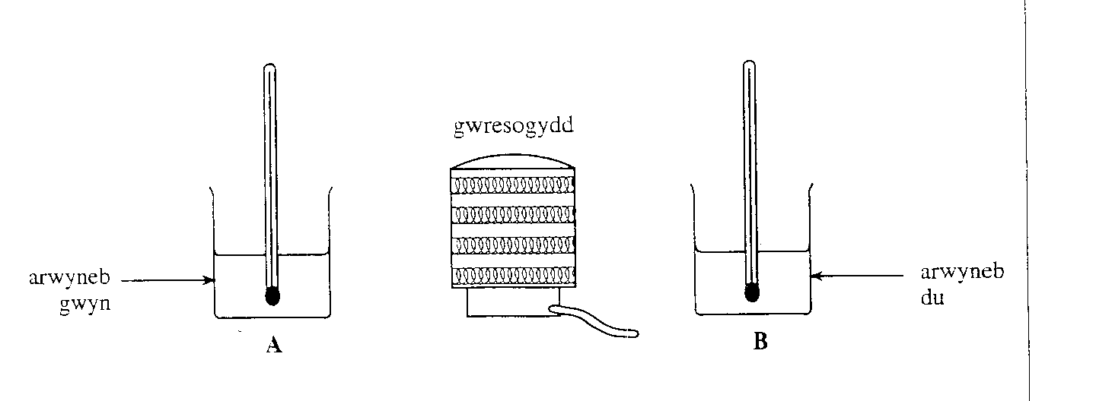
heater
white surface
black
surface

Study the graphs and discuss what has happened.

Try to explain why.

How did the teacher ensure that the test was valid?

What would be the effect of:
- having more water in the beakers?

- placing the beakers further away from the heater?

- using ‘bubblewrap’ instead of a white surface?

